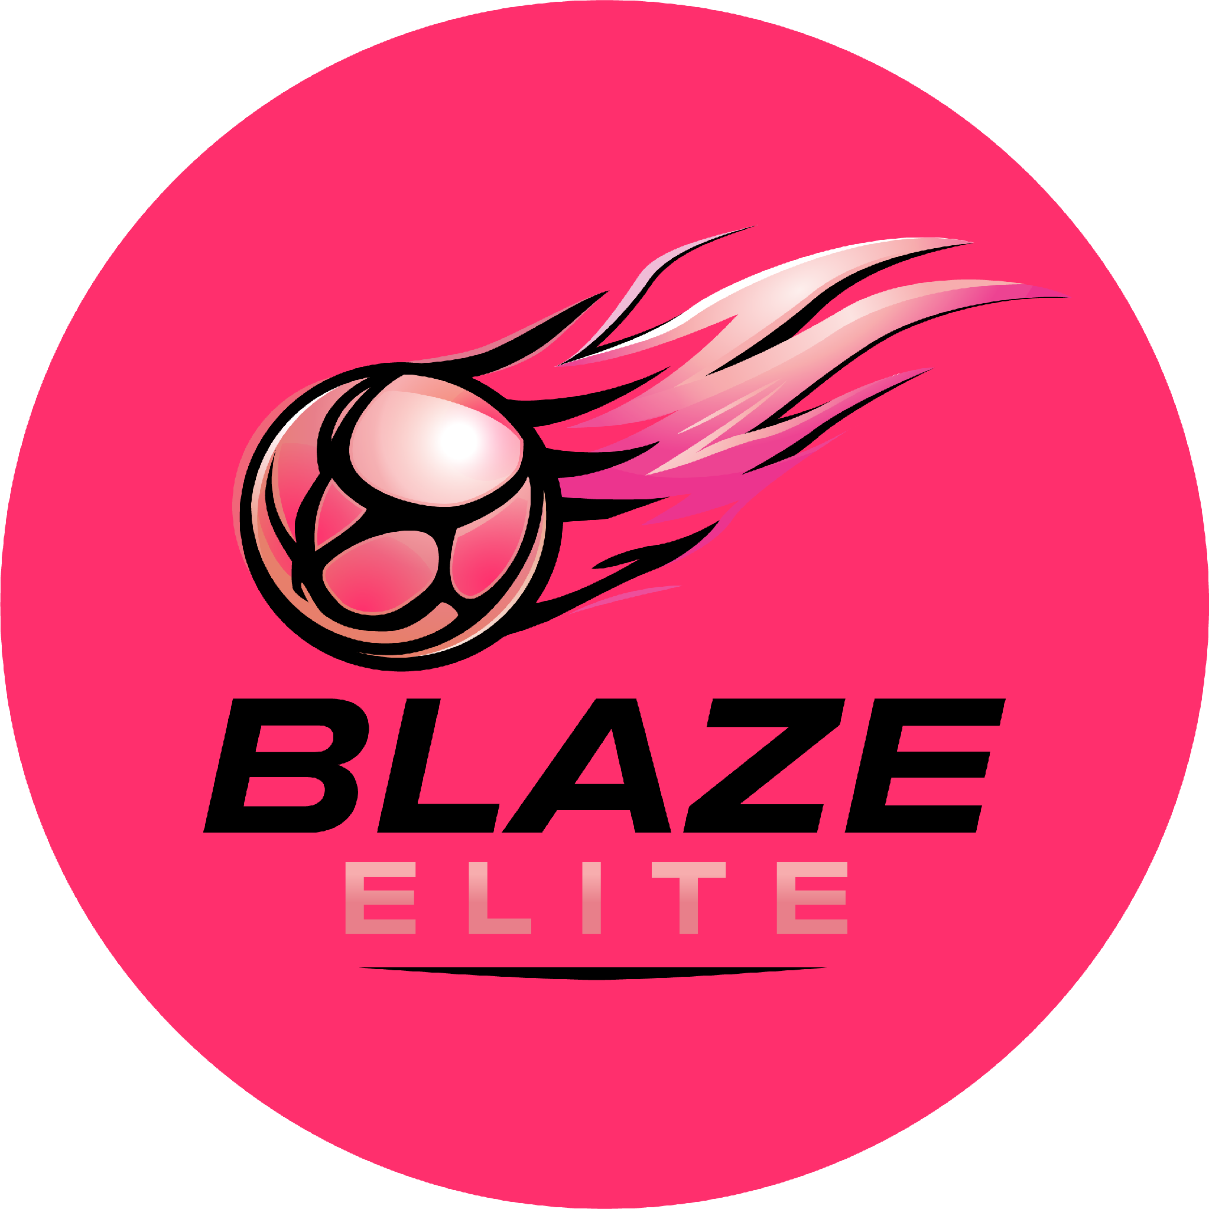

Complaints & Grievance Procedure
Blaze Elite Netball Club

1. Informal Resolution
Most concerns can be resolved informally. Coaching concerns should be raised with the Head Coach; general club concerns with any Committee member, in line with the relevant Code of Conduct.

2. Formal Complaint
Where a concern cannot be resolved informally, a formal complaint may be raised in writing with the Resolution Lead, , setting out the nature of the concern and any relevant detail.

3. Investigation
- The Resolution Lead will acknowledge the complaint promptly and investigate fairly, gathering relevant information from those involved.
- Where the complaint concerns a Committee member, another member of the Committee will lead the investigation instead.

4. Outcome & Appeal
The Resolution Lead will communicate the outcome and any resulting action to the complainant. Where the complainant is unhappy with the outcome, they may request the matter be reviewed by the full Committee.

5. Safeguarding Complaints
Any complaint involving a safeguarding concern is handled under the Safeguarding & Child Protection Policy, not this general procedure, and should be raised with the Safeguarding & Welfare Officer or England Netball's safeguarding team directly.

6. Escalation Beyond the Club
Where a complaint cannot be resolved at club level, England Netball's own Complaints Policy provides a further route, and can be accessed via englandnetball.co.uk or besafe@englandnetball.co.uk. See our Adoption of England Netball Policies document for further national policies that may also apply.

